ATTACHMENT C
CURRENT WEBSITE OFFERINGS

The Blair Telephone Company currently offers three speed tiers to fiber customers in the Blair, Nebraska area (symmetric speeds are available upon request – website is www.abbnebraska.com ):
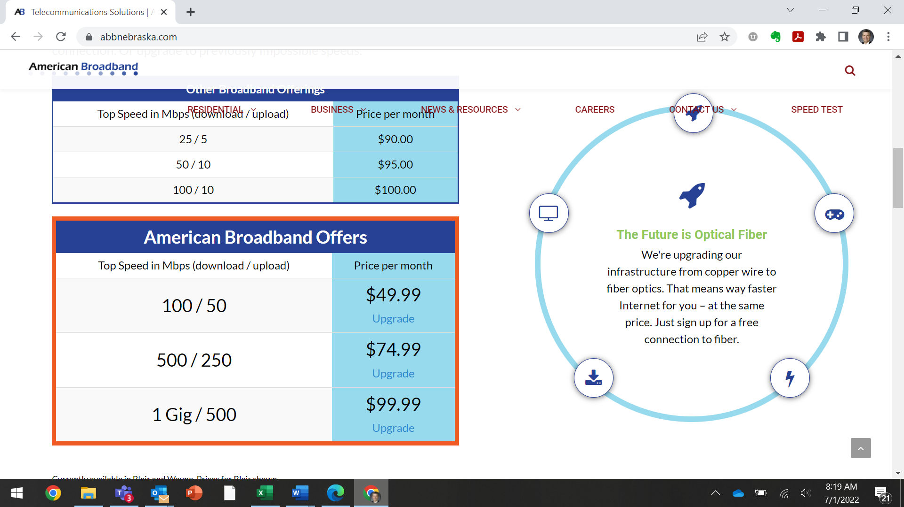

In addition, we also advertise on our website commercial symmetric speeds from 50 Mbps to 10 Gbps (website is here):
