ANNUAL REPORT REMINDER
March 1, 2022

This letter is the final reminder to complete the annual NUSF and State 911 Contact and Database update. All required information can be found on the Nebraska Public Service Commission website at:

https://psc.nebraska.gov/telecommunications/annual-report-compliance-information

All requested information is due to the Commission on or before April 28, 2022.

Please email the contact form and signed affidavit, in separate attachments, to: psc.telecom@nebraska.gov.

The Affidavit is required to be signed and notarized on a yearly basis by all Nebraska telecommunications providers. The Affidavit is required to certify compliance with Nebraska Universal Service Fund (NUSF) and Enhanced Wireless 911 statues, rules, and regulations, and Commission orders.

The Commission requires all companies, including wireline, wireless, Voice over Internet Protocol (VoIP), and paging companies to submit a regulatory contact for their company, including contact information. This contact information should be for the individual accountable for the regulatory responsibilities of the carrier. The correct regulatory contact information is critical to avoid additional fines and penalties which could result from delays in resolving violations of Commission orders, rules and regulations due to incorrect contact information.

Sincerely,
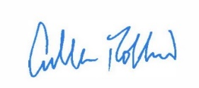
Cullen Robbins
Director of Communications
CR:sh

