ANNUAL REPORT REMINDER
March 1, 2021

This letter is the final reminder to complete the annual NUSF and State 911 Contact and Database Update, and Compliance Affidavit, and the Annual Report. All requested information is due to the Commission on or before April 30, 2021. There is no annual filing fee required.

All information regarding these items can be found on the Nebraska Public Service Commission website at:

https://psc.nebraska.gov/telecommunications/annual-report-compliance-information

We are encouraging carriers to complete and submit their annual reports digitally. Hard copies will be accepted, but digital submission is preferred. Reports can be submitted to the Commission at: psc.telecom@nebraska.gov

Questions regarding the annual report should be directed to Susan Horn at susan.horn@nebraska.gov and any financial questions should be directed to Steve Stovall at steve.stovall@nebraska.gov.

Sincerely,
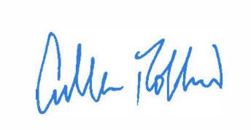
Cullen Robbins
Director of Communications
CR:sh

