**ATTACHMENT C**

**CURRENT WEBSITE OFFERINGS**

Huntel Cablevision (American Broadband) currently offers three speed tiers to fiber customers in the Blair, Nebraska area (symmetric speeds are available upon individual request – website is [www.abbnebraska.com](http://www.abbnebraska.com) ):

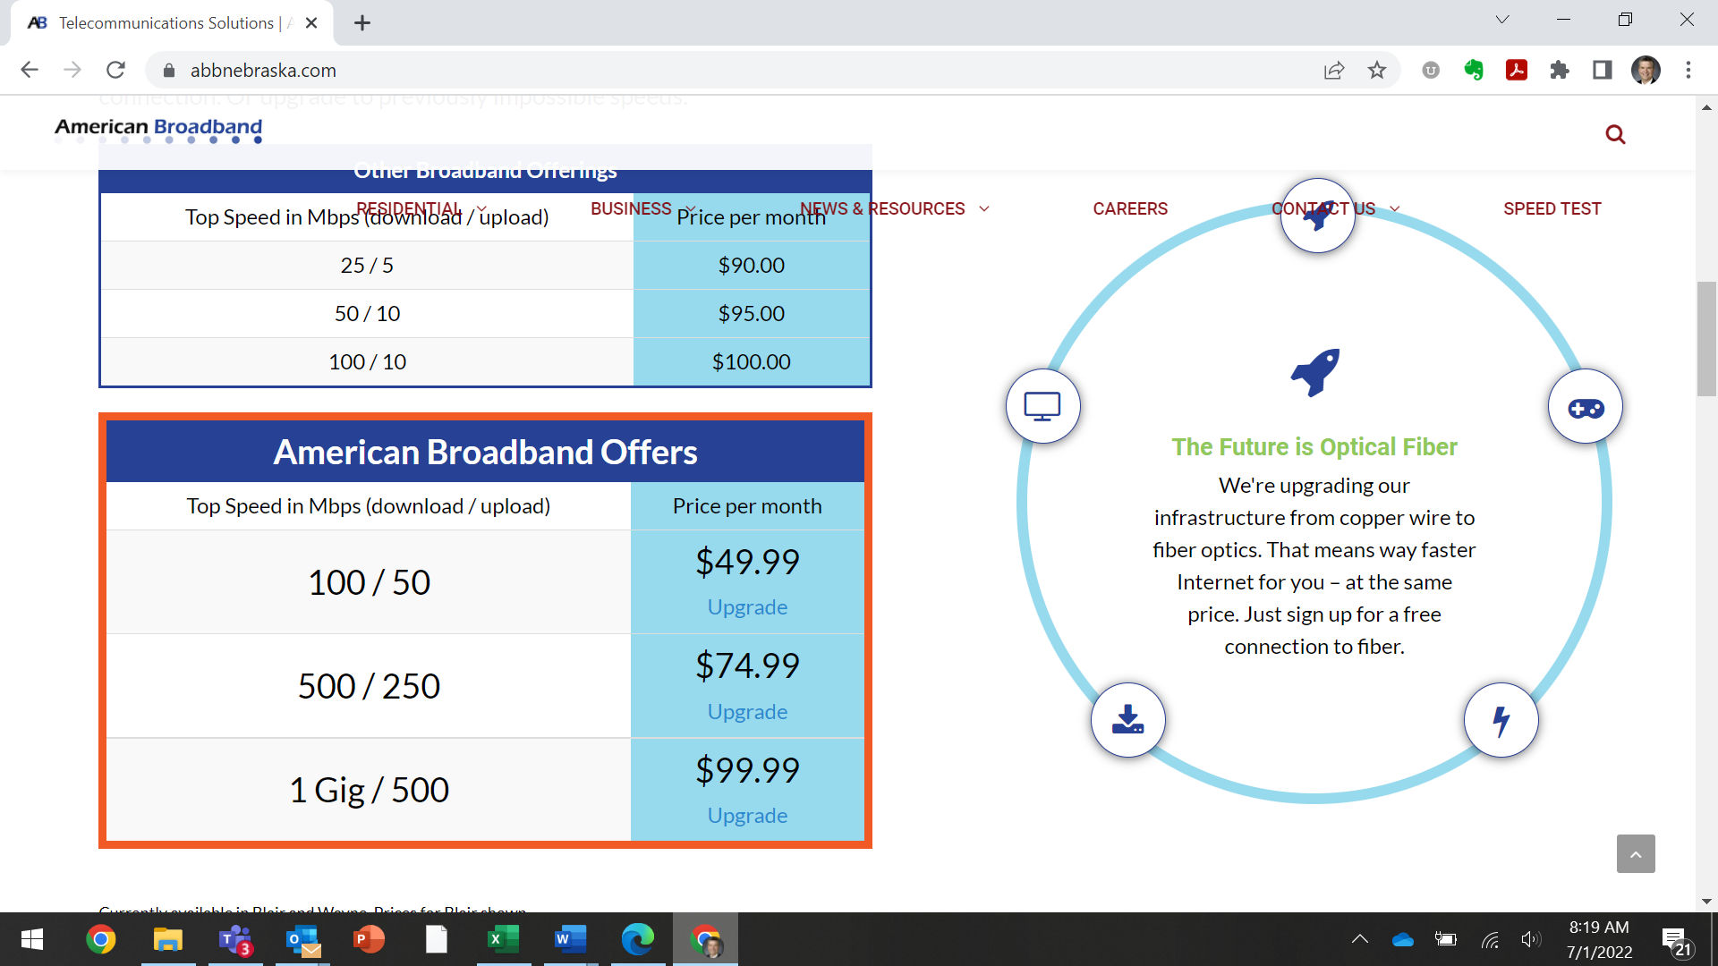

In addition, American Broadband also advertises commercial symmetric speeds from 50 Mbps to 10 Gbps (website is [here](https://www.abbnebraska.com/business-services/business-internet-solutions/ethernet-and-fiber/)):

