Attachment F

Rate Comparability

Cox Nebraska Telcom

Cox speeds and pricing for each community are advertised on the Cox website at our Nebraska website: https://www.cox.com/local/residential/ne. Users can click on the community and view pricing for the various speeds, as well as other services and packages available.

Our Everyday Low Price with WIFI 100mbps tier is $49.99 in Nebraska. Additionally, the retail rate will not include early termination fees, we do not do pay-as-you go, metered service, or lock customers into a particular plan or term. While we have data caps, we offer several options to meet the needs of our subscribers. Cox is committed to the ongoing management of its network to improve its service offerings, protect customers, and create new service and feature enhancements for its customers. Cox does not shape, block, or throttle Internet traffic or engage in other network practices based on the online content, protocols, or applications a customer uses or by a customer’s use of the network. Included in below are copies of the internet price sheets and terms and conditions from the Cox website.

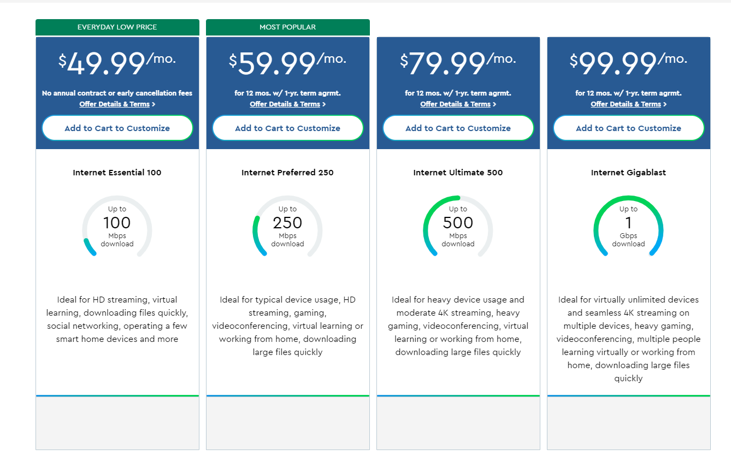

Internet Essential 100:
No annual contract means no minimum term period requirement and no early termination fees. Requires a DOCSIS 3.0 or higher modem. Use of a Cox-approved cable modem is required. Accessing your service via wifi may result in reduced Internet speeds due to the type of equipment used, environmental and structural conditions in your home, the number of users and other contributing factors. Uninterrupted or error-free Internet service, or the speed of your service, is not guaranteed. Actual speeds vary. See www.cox.com/internetdisclosures for complete Cox Internet Disclosures. Other restrictions may apply. All Cox Internet plans include 1.25 TB (1,280 GB) per month of data usage. Additional Data Plans can be added for an additional monthly charge. Excess usage is $10 per additional 50 GB block, except for Unlimited Data Plan subscribers. Unused data does not roll over. For more details on data plans and data usage, see cox.com/dataspeedplans and cox.com/datausage. Cox cannot guarantee the intended results from the McAfee® services or that the McAfee® software will be error-free, free from interruptions or other failures. The McAfee® services and features are subject to change. McAfee® is a registered trademark of McAfee®, Inc.

Data Add-On Details:
All Cox Internet plans include 1.25 TB (1,280 GB) per month of data usage. Unlimited and 500 GB Additional Data Plans can be added for an additional monthly charge. For data usage in excess of plan, 50 GB blocks of data will be automatically added for $10 each (max overage charge of $100 per month; $30 per month for ConnectAssist). Unused data does not roll over. See Speeds and Data Plans Information for more details on internet service and data plans. See cox.com/datausage for more details on data usage. Any customer within the Cox footprint can purchase data without purchasing additional products/services. Cox does not require any type of contract to obtain service with us but does make available term agreements with certain plans. A term agreement is a contract between Cox and the customer in which the customer agrees to keep covered services active in exchange for discounts and/or protection from price increases. Customers may qualify for term agreements on Internet, Video, Cox Voice, and Homelife Security services. The duration is typically 12 months or 24 months.

Non-Recurring charges include:
Installation Charges: Cox will not charge for a New Internet Pro Connect with or without Panoramic Wi-Fi. Restrictions - Internet service details. All services and plans subject to Cox's Residential Customer Term Agreement (including mandatory arbitration provisions), Acceptable Use Policy (including Cox’s right to terminate service for abuse of network), and other policies. See Annual Notice Information for related information and your privacy rights as a Cox customer. For all Cox Communications policies regarding our services and business practices visit www.cox.com/aboutus/policies.html.

Pricing and Policies:
Pricing, packages, and policies are subject to change, including when adjusting or removing services or equipment. Prices do not include applicable taxes, surcharges, usage-based charges (such as data, toll usage, pay-per-use service), and other fees. After any promotional period, regular rates apply (see www.cox.com). Prorated charges may appear on your bill if you change services before the billing cycle is complete. Rates, and/or when applicable, term agreements, may differ from those presented here as a result of customer’s account features, such as existing discounts, bundles, term agreements, or service address. Other restrictions may apply. All services and plans subject to Cox Residential Customer Service Agreement (including mandatory arbitration provisions), Acceptable Use Policy (including Cox’s right to terminate service for abuse of network), and other policies at: cox.com/policies.

