Attachment J
Digital Inclusion Plan
Cox Nebraska Telcom

Digital Inclusion Plan – Cass and Sarpy County
Capability and Community Engagement
Cox Communications is a long-trusted provider of telecommunications services in Nebraska, and we are excited to partner with the Public Service Commission in a meaningful way to meet our shared objective of closing the digital divide for all Nebraskans. In addition to our residential services, Cox Business has provided local businesses, industry, and government with commercial telephony since 1991. Since that time, Cox has invested more than $1 billion throughout our Nebraska market providing infrastructure upgrades and more than 5,000 miles of state-of-the-art-fiber-optic and HFC (Hybrid Fiber Coaxial) delivering video, phone and high-speed internet services to homes and businesses.
We have been proud to serve over 270,000 households and 14,800 businesses in Omaha and the nearby communities of Bellevue, Bennington, Gretna, La Vista, Elkhorn, and Offutt Air Force Base. We are committed to expand not only our multi-gigabit speeds to additional nearby communities, including those in Cass and Sarpy County, but to also work hand-in-hand with community leaders and service organizations to connect even our most disadvantaged neighbors.
Cox has a robust team on the ground living and working in Nebraska and understands the regional dynamics and needs. We understand the importance of serving and partnering with the communities in which our employees live and work. For us, it’s a mission and opportunity to use our time, talent, and technology in ways that strengthen cities, businesses, and future generations.
Our teams have a long-standing history of successfully partnering with local elected officials, school systems, places of worship, nonprofit organizations, public libraries, and local government programs designed to reach those in need of affordable connectivity. Our Cox leaders are also active on nonprofit boards and share our affordability and digital equity programs with other dedicated leaders in the region.
Cox Affordability Program Offerings
Cox offers multiple low-cost broadband connectivity options and has created affordable, digital equity programs like Connect2Compete (C2C) and ConnectAssist. We also provide educational resources through the Cox Digital Academy and other online tools and participate in federal assistance programs like the Emergency Connectivity Fund (ECF) and Affordable Connectivity Program (ACP) which uniquely position us as a ready and willing partner to deliver on our connectivity and digital inclusion promise.
Even before the COVID-19 pandemic emphasized the importance of connectivity, Cox recognized the need for affordable access, particularly for households with school-aged children. Since 2013, Connect2Compete has been available for all qualifying customers in communities Cox serves. Thanks to a multimillion-dollar investment, the price of $9.95 per month and benefits like no equipment rental fee, no deposits, no long-term contracts, and no installation fee have not changed. Today, Connect2Compete customers receive speeds up to 100 Mbps - a number that has increased tenfold since the program’s inception, again, without impacting the monthly cost for the service.
Our success with Connect2Compete and the increased need for high-speed connectivity led Cox to introduce ConnectAssist, a low-cost broadband connectivity option for any household that qualifies for government assistance programs like SNAP, Pell Grant, Veterans Pension, SSI, and more. This program was introduced to help people transition to the increased emphasis on virtual connectivity, beyond families with K-12 students. For $30 per month, ConnectAssist customers receive a wired, in-home connection with a Wi-Fi enabled router that provides speeds up to 100Mbps. These programs are in addition to our several low-cost service offerings available to all Cox customers.
Emergency Connectivity Fund & Affordable Connectivity Program
As mentioned, Cox is a proud participant in the Federal American Connectivity Program (ACP), which enables eligible households to apply a $30 monthly broadband credit ($75 in Tribal areas) to any of our service offerings. When combined with Cox’s low-cost offers, ACP could bring a household’s internet bill to $0.00 per month.
Cox is also an active partner in the FCC’s Emergency Connectivity Fund (ECF) program which provides funding to schools and libraries to bridge the technology and broadband connectivity gap for off-campus connectivity for students, school staff, and library patrons who would otherwise lack sufficient connectivity to engage in remote learning.
Cox 100/100 Mbps Plan
Cox speeds and pricing for each community are advertised on the Cox website at our Nebraska website: https://www.cox.com/local/residential/ne. Users can click on the community and view pricing for the various speeds, as well as other services and packages available.
Our everyday low price with Wi-Fi 100/100 Mbps tier is $49.99 per month. Additionally, the retail rate will not include early termination fees, we do not do pay-as-you go, metered service, or lock customers into a particular plan or term. Cox is committed to the ongoing management of our network to improve service offerings, protect customers, and create new service and feature enhancements for our customers. Cox does not shape, block, or throttle Internet traffic or engage in other network practices based on the particular online content, protocols or applications a customer uses or by a customer’s use of the network.

Digital Literacy
To support digital literacy, Cox provides access to “The Cox Digital Academy” in partnership with the American Library Association, providing digital literacy resources in English and Spanish for families, educators, community leaders, and students. The robust suite of digital literacy tools features computer literacy tips, educational resources, and online safety & security tutorials. In addition, the Digital Academy provides access to MyFuture, a digital platform from the Boys and Girls Club of America that empowers children and teens to learn new skills, share accomplishments, and earn recognition and rewards via gamification in a safe and fun online environment. For more information, visit Cox Digital Academy.
In addition, Cox is always pursuing new digital equity partnerships and has recently onboarded five new national organizations, supported by an online portal designed to recruit new partners. The program provides a marketing kit for non-profit partners who serve the targeted low-income segment to promote our programs to eligible households. We are currently evaluating the expansion of one of these partnerships to bring private and public sector business leaders together to work on solutions to improve digital inclusion. Cox is ready to offer materials and resources in multiple languages to support all residents in the county. This is in response to the fact that 14% of the Hispanic population and 12% of the Latino population in this region, as identified through census respondents, reported speaking a language other than English at home.
Addressing Critical Needs in Cass and Sarpy County
According to the 2022 Census, approximately 6.4% of Cass County residents live in poverty, 2.1% of county residents are unemployed, 8.9% experience a form of disability, and 29.8% of county residents have a bachelor’s degree or higher. Approximately 6% of Sarpy County residents live in poverty, 2.0% of county residents are unemployed, 13% experience a form of disability, and 43.4% of county residents have a bachelor’s degree or higher Broadband plays a critical role in business development, employment, education, healthcare, housing, and other publicly desired services, as it is the community’s connection to future economic growth. Broadening our service footprint will allow us to engage even more diverse and successful partners in Cass and Sarpy County to support our mission of connecting the un- and underserved, ensuring that residents can use their services designed with equity in mind, and closing the digital divide.
In Cass and Sarpy County respectively, 14.4% and 6.6% of households have no broadband internet subscription. By choosing Cox and our all-fiber network that delivers multi-gigabit speeds, un- and underserved residents and businesses in Cass and Sarpy County will achieve digital equality. As highlighted above, access to internet services has significantly positive impacts on families pursuing educational opportunities, receiving timely telehealth, and the potential for increased work opportunities – such as remote work. Once deployed, broadband will no longer be a barrier to retaining residents and will be an ignitor for businesses. This will enable residents to learn, work, or manage their health with strong connectivity; and businesses will be more likely to consider doing business in a technologically modern community.
Telework and Workforce Training

In a report issued by the Pew Research Center (February 16, 2022), roughly six out 10 U.S. workers who say their jobs can mainly be done from home are doing so all or most of the time. But, without a fast, reliable broadband connection, telework isn’t an option. Neither is having the ability to take online courses, training, or even search and apply for jobs. Given the current economic environment across the country, Americans who have lost their jobs due to layoffs or downsizing are put at a disadvantage if they do not have a reliable internet connection; they’re unable to receive real-time job notifications and may have difficulty completing online job applications. According to the Institute of Labor Economics, unemployed Americans seeking employment are 3-4% more likely to find a new job as an effect of broadband availability.

Cox’s fiber-to-the-home network will connect homes to multi-gig speeds, and the number of devices that can be connected to the internet simultaneously are virtually endless. This connectivity will support a host of applications associated with remote work including uploading and downloading large files and seamless 8k streaming.

Remote Learning

In addition to our strong commitment to our customers, Cox has long been committed to bridging the digital divide and has launched unprecedented pricing plans, educational resources, and partner programs to overcome barriers obstructing digital inclusion. With this history, tradition, and experience, we look forward to being able to extend our affordability programs to Cass and Sarpy County. We know that without a reliable connection, the homework gap (students unable to complete homework assignments because they don’t have reliable access to a computer or internet connection) grows which puts these students at a disadvantage and at risk for dropping out, not pursuing post-secondary education, and decreased lifetime earnings, ultimately continuing the cycle of poverty and directly impacting the community’s economic vitality.

New Housing Starts

According to the National Association of Realtors, a home’s value is directly impacted by the availability of a broadband internet connection. They report that homeowners lose nearly 3% of their home’s value by not having broadband. On the flip side, a fiber-to-the-home connection, capable of delivering multi-gigabit speeds, as we’ve presented in our application, can raise a home’s value by more than 3%. Higher home values translate to an increase in tax revenues, thus contributing directly to the economic viability of a community.

The Cox team is experienced in working directly with developers and builders to communicate the benefits of including broadband connectivity as a part of construction plans for both efficiency and for increased home values.

Telemedicine

In 2017, Oklahoma State University published an article Evaluating the Economic Impact of Telemedicine in a Rural Community. Authors Whitacre, Hartman, Boggs, and Schott identify and quantify four distinct benefits of telemedicine use in a rural community: Hospital cost savings from outsourcing, patient savings on travel time and expense, patient savings from fewer missed hours of work, and dollars captured in local economies from using local health services like labs and pharmacies.

With Cox’s fiber-to-the-home broadband connectivity, residents will be able to conduct video calls with medical providers, manage their health through online record-keeping, scheduling, and payment portals, and upload and download relevant medical information to their doctors quickly and securely.

Home Automation
Another benefit of fiber broadband connectivity is the ability to support home automation applications. Automated or “connected” homes not only allow homeowners to keep up with the latest technology, but there are also practical advantages to home automation. With the ability to manage all your devices in one place, convenience rises to the top of the list. Automation can also provide peace of mind with home security features including the ability to turn lights on and off remotely, lock/unlock doors, and check security cameras and motion sensors. And while home automation may sound fancy and frivolous, it can actually improve appliance functionality and energy efficiency, translating to cost savings over time.

Emergency Services
Infrastructure and technology have become the backbone of emergency response. It is heavily relied on for real-time, clear, and proper communication in what are oftentimes matters of life and death. A fast, reliable connection can improve response time, enhance coordination between agencies, and keep our first responders safe. An article in Mission Critical Communications earlier this year (McHugh) shares some of the current challenges for first responders. He states that, “Lack of interoperability between first responders is a fundamental disparity in modern public safety and largely a consequence of not having access to technology that enables interoperable broadband communications.” He goes on to mention that a major gap in capability during emergencies can be attributed to inadequate access to applications and sharable information due to “a lack of a dedicated high-speed data network to distribute them.” These public-safety broadband networks provide benefits that are leaps and bounds over the traditional voice-only two-way radio or “push to talk” solutions that still exist in areas where a broadband backbone isn’t available to support the high-bandwidth needs of PSBNs.

Benefits to Farmers

Data collected from a report conducted by the Benton Institute for Broadband & Society (https://www.benton.org/publications/future-american-farming) revealed that access to fast, affordable, and reliable broadband will strengthen America’s rural communities. It will allow for more reliable and efficient food production for a growing population and will also increase sustainability. Farmers have always relied on data, but today, fast, real-time access to that data and the ability to quickly analyze and subsequently use the information is key for the efficient and targeted use of resources and the ability to implement innovative agricultural practices. The report further indicates that managing digital data drives precision agriculture which in turn drives productivity and sustainability – two factors that cannot be overlooked as the world’s population continues to grow.

And, according to an article published by the World Economic Forum, real-time weather forecasting helps farmers with day-to-day decisions on when and how much to irrigate, fertilize, and apply pesticides to their crops. A strong broadband connection can also enable smart greenhouses that are completely automated to ensure optimal conditions for plant growth.

Cox Community Support - Disadvantaged Community Engagement

In Nebraska, Cox supports communities through cash, grants, and in-kind contributions. Since 2012, Cox has focused on maximizing community partnerships to close the digital divide and support both access and adoption goals necessary to achieve digital equity.

Our goal is to improve educational access and help shape the lives of children and families who do not have regular access to the internet to do homework, research their interests and prepare for jobs of the future. Since the start of the pandemic, Cox has connected over 250,000 individuals nationally to the internet through our low-cost programs. As a committed community partner, we want to support economic development initiatives by ensuring that any resident or business within our existing or future footprint has access to the best broadband available in the industry.

Cox recognizes the positive impact of school readiness; STEAM (Science, Technology, Engineering, Arts and Mathematics) education programs and the effect accessibility and connectivity can have on a child’s scholastic trajectory. Focusing on youth and education is a primary focus area for Cox Charities. Each year, Cox partners with education-based charitable organizations to jumpstart education initiatives for kids across the region. In 2020, Cox awarded $130,000 to Nebraska non-profits and educators and connected more than 1,600 households with K-12 students in Nebraska to its affordable home internet program.

The targeted service area will benefit considerably, not only from reliable, fast service, but also enrichment from the many outreach programs and charity work that Cox provides to its communities. In addition to our ongoing partnerships with organizations like Seventy-Five North, Boys and Girls Clubs, South Omaha Club, and Habitat for Humanity-Omaha, we have proactively identified additional non-profit organizations that serve Cass and Sarpy County communities who would be great partners to help us educate and connect the un- and underserved with a focus on broadband affordability options and digital literacy.

Cox Community Impact
Building and fostering strong relationships with community-based and non-profit partners is a critical component of our work. Cox has a vast network of national, state, and local partnerships and is the largest family-owned telecommunications provider in the nation. In Nebraska, Cox generates $960 million in economic activity and supports 3,422 jobs. Cox also invests over $60 million annually in technology infrastructure construction projects statewide, generating $115 million in economic activity. Further, through cash and in-kind gifts like grants and broadcast airtime, Cox actively engages with the community to provide aid to support essential initiatives like those required during the COVID-19 pandemic.
Cox Communication’s Contribution to Nebraska:
Economic Impact: $960M
Total Employees: 800
Wages paid: $47.5M
Jobs Supported*: 3,422
Taxes and Franchise Fees: $35M
Broadband Network (Miles): 5,000+
*Total number of jobs that are sustained or created as a result of a certain economic activity, investment, or industry
Addressing COVID-19 Public Health Emergency Critical Needs
The COVID-19 public health emergency highlighted the importance of connection and the real power of technology to bring us closer to one another at a time when it’s most needed. Internet connectivity was and remains more important than ever as millions of people across the country connect to work, school, medical professionals, and their families from home. Cox took action to ensure that our employees, customers and partners, and the broader communities in which they live, have robust, reliable network connectivity and assurance that they can use their service as needed.
Cox deployed numerous strategies during that time to ensure continuity of service, including:
- Permanently increasing the speed of the Connect2Compete program to support families in greatest need,
- Suspending late fees and extending payment relief offerings for Connect2Compete customers who express an inability to pay due to pandemic hardships,
- Offered immediate access to 3M+ Cox Hotspots nationwide,
- Partnered directly with school districts to get devices and services into the hands of students and families, and
- Launched a social media campaign that drove 24 million impressions to raise awareness of C2C, among other interventions.
COVID uncovered ways for us to leverage resources - both dollars and people – and we continue to amplify the lessons learned and be mindful to find ways to bring our conversations with key decision-makers in the community back to C2C and other broadband connectivity solutions.
Outreach and Marketing Efforts – Facilitating Adoption
To support adoption, Cox understands that it is important to develop grassroots connections and relationships with other organizations committed to bridging the digital divide in addition to traditional marketing and sales strategies. Over the past few years, Cox has established more than 170 national and local partnerships to collaborate on this initiative. Our vital national partnerships include Connect Home USA, Everyone On, American Library Association, Common Sense Media, Boys and Girls Clubs of America, and Big Brothers/Big Sisters. As indicated prior, Cox recently onboarded five new national organizations, supported by an online portal designed to recruit new partners. The program provides a marketing kit for non-profit partners who serve the targeted low-income segment to promote our affordable broadband programs to eligible households. This effort brings private and public sector business leaders together to work on solutions to improve digital inclusion. To support current and future expansion projects, Cox also created educational videos explaining what to expect during the construction and installation process to better educate local leadership and residents.

In addition to engaged community partners, Cox actively promotes its products and services through multi-faceted marketing campaigns that include both direct and indirect sales, outdoor billboards, digital advertising, television and radio commercials, and outreach through partnerships such as the Omaha Public Schools’ digital newsletter. It is likely that many Cass and Sarpy County residents have seen advertisements for Cox services already due to its proximity to the city of Omaha. In addition to our national media campaigns, Cox airs public service announcements for our Connect2Compete program and has set up a dedicated website highlighting our digital equity offers and providing a link to apply for ACP benefits at www.cox.com/digitalequity.
Outreach to Stakeholders in Cass and Sarpy County – Sharing our Plans
Cox Nebraska Telcom appreciates the opportunity to show our commitment to bridge the digital divide in the state of Nebraska, for the needs of today and into the future. We applaud the Commission’s dedication to increasing the availability and effectiveness of broadband internet throughout the state, particularly for un and underserved residents, businesses, and their communities, as you work towards a fully connected citizenry, both economically and socially.

Cox recognizes the importance of managing grant funds prudently so that the greatest number of un- and underserved locations can be served.
As a committed community partner, conducting outreach and generating significant community partnership support for our grant applications is a critical component in accomplishing our shared goal of closing the digital divide in Nebraska. We want to ensure that any resident or business within our existing or future footprint has access to the best broadband available in the industry, which is why we support over 70 non-profit organizations, including aforementioned partners such as Boys and Girls Club, Habitat for Humanity, and Big Brothers/Big Sisters. We share our expertise by serving on local boards and encourage and provide paid time off for our employees to volunteer in the community. Additionally, we are active members in our local Chambers of Commerce, including Sarpy, Washington, and Dodge Counties and look forward to potentially adding membership to the Cass County Chamber of Commerce with the expansion of this project.
Cox stands ready as a resource and partner in the expansion of broadband availability in Nebraska, and our local teams have collected a great deal of community feedback by working closely with county and municipal leaders, non-profit organizations, community & business institutions, public safety groups, and citizens. These “boots on the ground efforts” and hundreds of volunteer hours have been invaluable in truly learning the individual needs of the great communities that are the backbone of Nebraska. As a result, and in support of Cox’s infrastructure deployment goals within Cass and Sarpy County, we received multiple letters of support from a variety of community stakeholders. These stakeholders include community partners, government representatives, institutional and private partners.
All the letters expressed appreciation and support for Cox’s submission and demonstrated a compelling level of need and lack of comprehensive coverage for reliable internet services, which Cox is hoping to bring to the county.

Appendix:

- Affordability and Digital Equity Programs
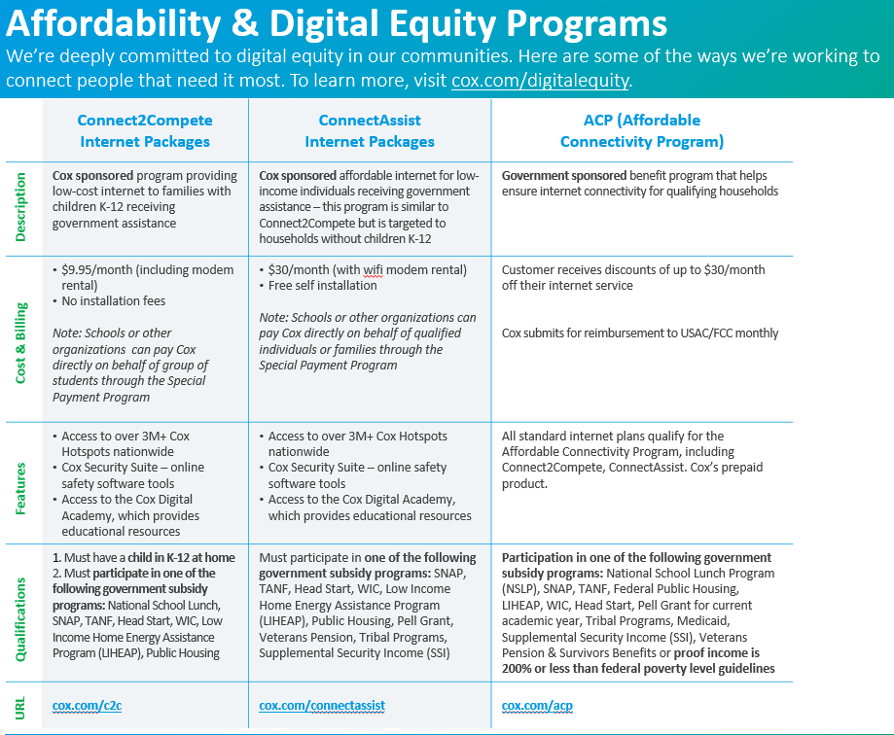

- Marketing - Affordability Programs
