Qwest Corporation d/b/a CenturyLink QC
Westpoint NE NBBP/CPF Grant Application

Digital Inclusion Plan and Low-Income Assistance Programs
In a funding partnership with the State of Nebraska, CenturyLink QC will improve unserved/underserved levels to 940 Mbps download and upload speeds, exceeding the NBBP/CPF speed requirement. Building a fiber-to-the-premise network that provides advanced, high speed broadband services to households, businesses, and farms in the proposed grant area improves access to critical school e-learning applications while also making agricultural operations more efficient and enhancing crop production through enabled precision agriculture tools. The broadband network will also enable remote working scenarios, improve access to rural health care resources and will stimulate a more robust local area economy.

The company participates in the Affordable Connectivity Program (ACP) for qualified low-income customers. Information about this program is located at the following website:
https://www.centurylink.com/home/help/account/consumer-assistance-programs.html
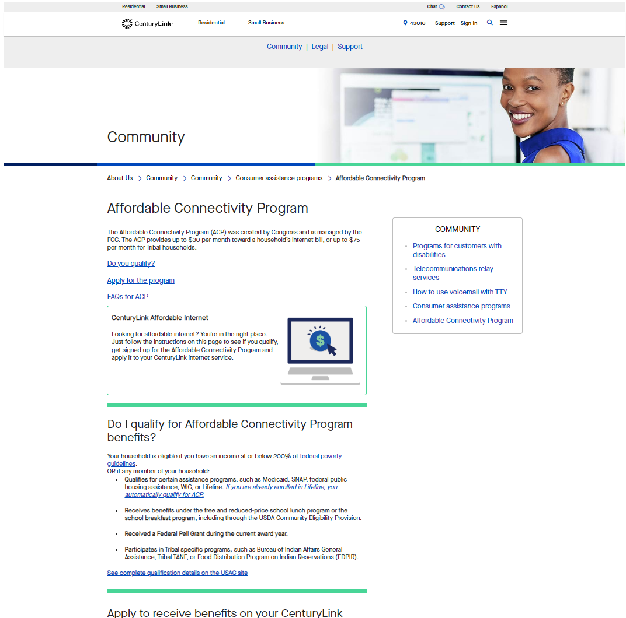

The company also participates in the FCC Lifeline program. Information regarding this program is located at the following website:
https://www.centurylink.com/home/help/account/consumer-assistance-programs.html
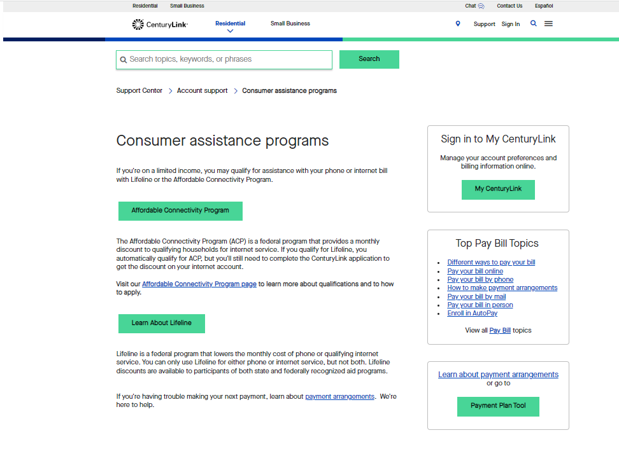
Qualified low-income customers can subscribe to these programs and receive offsetting monthly credits for high-speed fiber internet service to cover a significant portion of the monthly charge. (ACP - $30, Federal Lifeline - $9.25) The pricing for high-speed fiber internet service can be found at the following website link:
https://www.centurylink.com
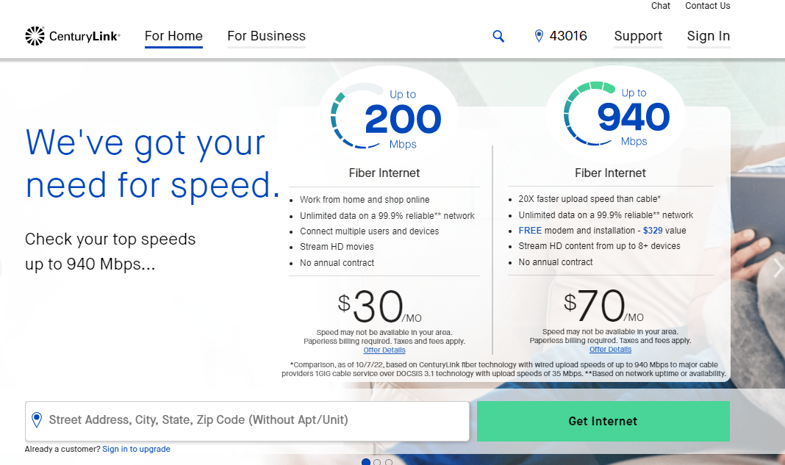

Low-Income Offer:
If a customer qualifies for ACP and subscribes to the 200M offering at $30 per month, the benefit will essentially negate the cost of the service excluding optional equipment rental. Since all customers covered by the grant project will have fiber to the premise, all customers will receive 200 Mbps symmetrical (upload and download) service.
CenturyLink provisions each customer for 200 Mbps symmetrical upload/download. Actual results can differ based on network congestion and/or capabilities of customer provided equipment. There are no set minimum speeds for the offering.
CenturyLink’s pricing for fiber internet services in grant areas, is the same pricing it uses in very competitive areas, such as Omaha, Salt Lake City, Phoenix, Denver and many other cities that have multiple providers offering 1-gig service. Since the company utilizes nationwide pricing for its fiber internet services, customers in grant areas get the same competitive pricing and benefits as customers in big cities.

Awareness and outreach:
Prior to applying for this NBBP/CPF grant, CenturyLink QC contacted community leadership as evidenced in the attached. The company looks forward to any feedback from the community as a result of this outreach and potential future collaboration as appropriate.
Consistent with the requirements in the National Telecommunications and Information Administration (NTIA), Broadband Equity, access, and Deployment (BEAD) Program the company plans to “carry out public awareness campaigns in their service areas that are designed to highlight the value and benefits of broadband service in order to increase adoption of broadband service by consumers. Awareness campaigns must include information about low-cost service plans and any federal subsidies for low-income households such as the Lifeline Program, the Affordable Connectivity Program, and any successor programs. Further, awareness campaigns must be conducted in an equitable and nondiscriminatory manner. Subgrantees must utilize a variety of communications media (e.g., online, print, radio) and provide information in languages other than English when warranted based on the demographics of the community”.
The company has experience from other states about what marketing activities works best in grant areas. For all awarded project areas as they near completion, the company will develop the specific marketing plan for each area, which at minimum will at least include the following:
- Direct Mailing: To be sent to all fiber enabled customer locations to notify them of the availability of fiber based HSI in their area.
  - Within this promotional material will provide references to where low-income customers can find out more about the ACP/Lifeline program and low-income offers.
- Coordination with local government and community leaders: To help educate and increase awareness of fiber HSI availability within the area, especially how to best reach low-income customers.

Other marketing activities that may be utilized:
- Digital marketing, such as pop up adds on internet sites.
- Door hanging promotional information about the availability of fiber HSI services.

IV. Public Notice: page 68 of the NTIA’s BEAD Program Notice of Funding Opportunity: https://broadbandusa.ntia.doc.gov/sites/default/files/2022-05/BEAD%20NOFO.pdf
The company is continuing to try and test new marketing and advertising tactics. At the time a grant award project completes, the company will utilize the best approach for the grant area, to maximum the take rate. Given the amount of investment the company will be making in support the grant area projects, there is a strong incentive to sign up fiber internet service customers as fast as possible.

