Qwest Corporation d/b/a CenturyLink QC
Loup City NBBP/CPF Grant Application
Once construction is complete for this project, CenturyLink QC may be providing services to residents under our Quantum Fiber brand. Availability and current pricing can be found at https://www.quantumfiber.com/homepage.html and is shown below.
Speed | Price | WiFi Router
500Mbps/500Mbps | $50.00/month (plus taxes & fees) | Included
940Mbps/940Mbps | $75.00/month (plus taxes & fees) | Included

Quantum Fiber’s offering is for symmetrical upload/download speeds. This is explained in the Actual network performance metrics section of our Internet Service Disclosure found here https://www.quantumfiber.com/legal.html .
There are no term limits, contracts to sign or early termination fees for these services. The company does not apply data caps or speed throttling to its services and does not offer metered “pay-as-you-go” services. Additionally, the company is currently offering “price for life”. With this offer, customers keep their internet service monthly rate for as long as they keep their plan.
An example on the Quantum Fiber website:
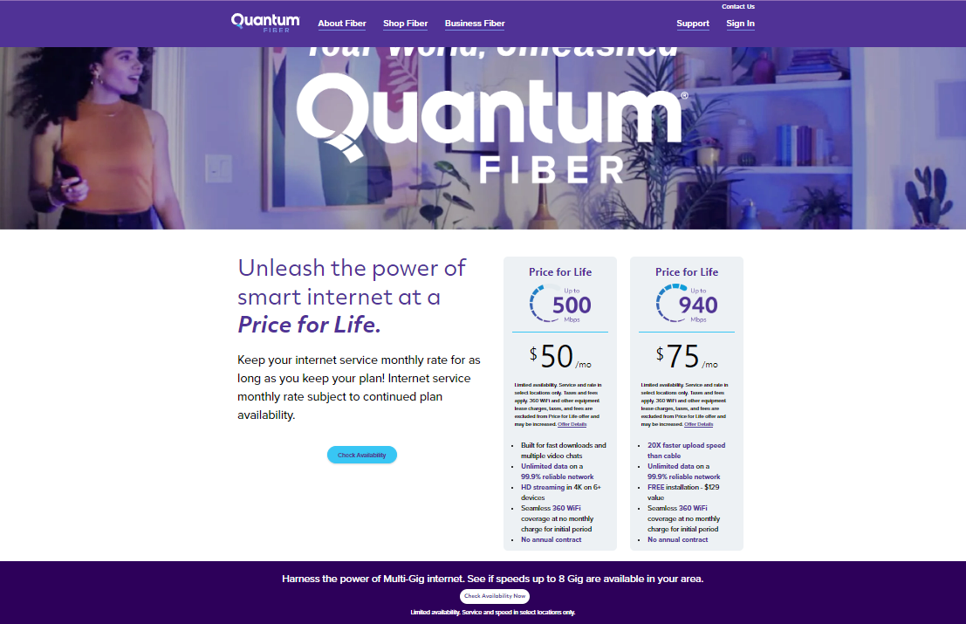
CenturyLink QC commits pricing for our minimum 100 Mpbs broadband service will be at or below the FCC’s 2024 urban rate survey broadband services benchmarks throughout the 5-year commitment period. Summary of benchmarks from the FCC 2024 urban rate survey for minimum 100 Mbps to 1000 Mbps shown below.
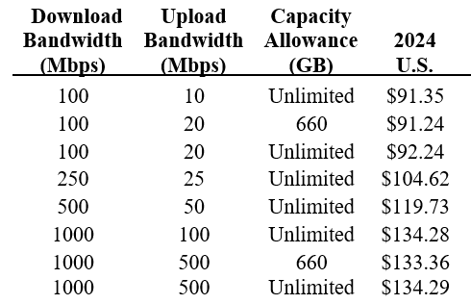

Offer details can be found by selecting “offer details” at the following location https://www.quantumfiber.com/homepage.html
Public Notice from the Wireline Competition Bureau and Office of Economics and Analytics DA23-1207. https://www.fcc.gov/document/revised-2024-urs-broadband-services-benchmarks-and-waiver

