CenturyLink QC
Chadron NBBD Grant Application
Once construction is complete for this project, CenturyLink QC will be providing services to residents at the same location where they can see their available services today, at https://www.centurylink.com/
Pricing for CenturyLink QC broadband service is established at a national level and currently priced at
Speed | Price | WiFi Router
100Mbps/100Mbps | $50.00/month (plus taxes & fees) | $15/month
750Mbps/750Mbps | $65.00/month (plus taxes & fees) | $15/month

There are no term limits, contracts to sign or early termination fees for these services. CenturyLink QC does not apply data caps or speed throttling to its services and does not offer metered “pay-as-you-go” services.
An example on the CenturyLink website:
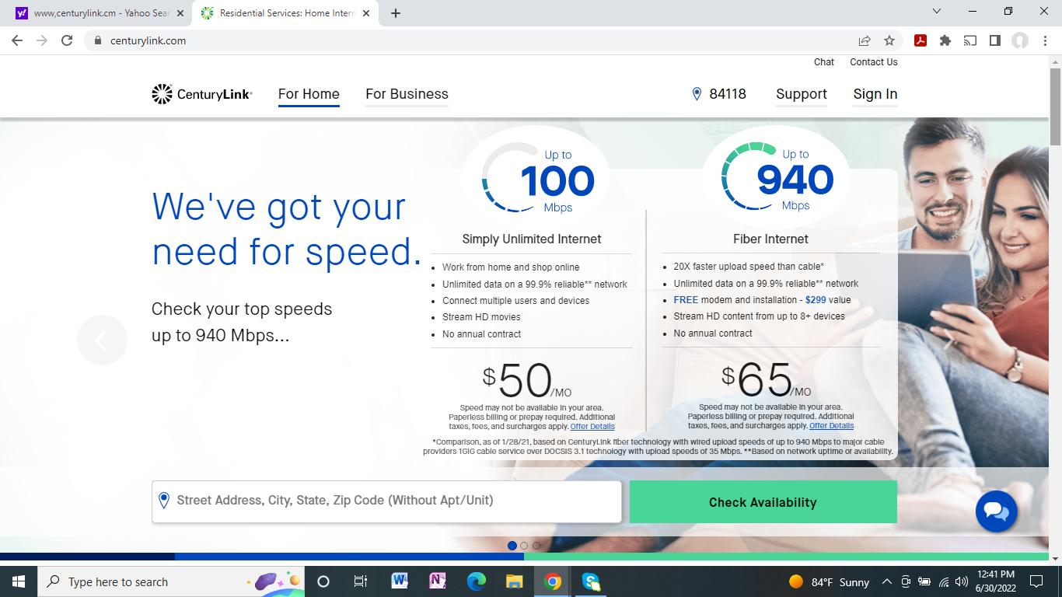

While CenturyLink plans to offer symmetrical 750Mbps in Chadron, the 940Mbps service is also priced at $65.

