Qwest Corporation d/b/a CenturyLink QC

Valley Waterloo NBBP Grant Application

**Digital Inclusion Plan and Low-Income Assistance Programs**

In a funding partnership with the State of Nebraska, CenturyLink QC will improve unserved/underserved levels to minimum 500 Mbps download and upload speeds, exceeding the NBBP speed requirement. Building a fiber-to-the-premise network that provides advanced, high speed broadband services to households, businesses, and farms in the proposed grant area improves access to critical school e-learning applications while also making agricultural operations more efficient and enhancing crop production through enabled precision agriculture tools. The broadband network will also enable remote working scenarios, improve access to rural health care resources and will stimulate a more robust local area economy.

The company also publishes materials to encourage digital literacy, found at the following link: <https://www.quantumfiber.com/support/internet-essentials.html>

Internet Essentials is a hub of internet information meant to meet the needs of our customers who have a more basic level of familiarity with the internet and who are looking to build their digital literacy skills and knowledge. Topic areas include modem set up, Wi-Fi basics, online security, speed, and lifestyle topics. The company plans to continue to expand this collection and grow the knowledge base. The company also provides many instructional videos, available on our corporate website and YouTube. Topics include boosting Wi-Fi performance, and support.

Example links below:

<https://www.youtube.com/playlist?list=PLEYIeiCR-pz4qPNeOjBdQGXWoKHXY9glG>

<https://www.youtube.com/results?search_query=quantum+fiber+how+to+videos>

CenturyLink QC and our Quantum Fiber brand participated in the Affordable Connectivity Program (ACP) for qualified low-income customers before it was discontinued and expects to participate in the future if it is renewed.

The company participates in the FCC Lifeline program.  Information regarding this program is located at the following website:

<https://www.centurylink.com/home/help/account/consumer-assistance-programs.html>

Qualified low-income customers receive offsetting monthly credits for high-speed fiber internet service to cover a significant portion of the monthly charge (Federal Lifeline - $9.25). Applying the $9.25 Lifeline credit to the current lowest offering of $50 per month for 500 Mbps symmetrical service meets the NBBP low-income guideline of less than $50 per month.

Current pricing for high-speed fiber internet service with our Quantum Fiber brand can be found at the following website link:

<https://www.quantumfiber.com/homepage.html>

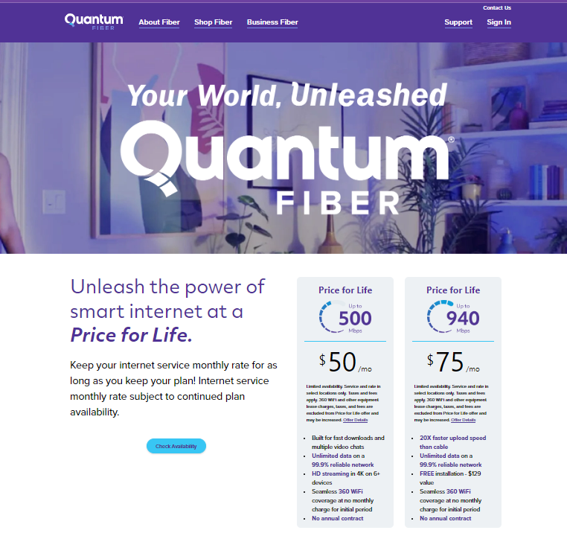

CenturyLink’s pricing for fiber internet services in grant areas, is the same pricing it uses in very competitive areas, such as Omaha, Salt Lake City, Phoenix, Denver and many other cities that have multiple providers offering 1-gig service. Since the company utilizes nationwide pricing for its fiber internet services, customers in grant areas get the same competitive pricing and benefits as customers in big cities.

**Awareness and outreach:**

Prior to applying for this NBBP grant, CenturyLink QC contacted community leadership as evidenced in the attached. The company looks forward to any feedback from the community because of this outreach and potential future collaboration as appropriate.



Consistent with the requirements in the National Telecommunications and Information Administration (NTIA), Broadband Equity, access, and Deployment (BEAD) Program the company plans to **“*carry out public awareness campaigns in their service areas that are designed to highlight the value and benefits of broadband service in order to increase adoption of broadband service by consumers. Awareness campaigns must include information about low-cost service plans and any federal subsidies for low-income households such as the Lifeline Program, the Affordable Connectivity Program, and any successor programs. Further, awareness campaigns must be conducted in an equitable and nondiscriminatory manner. Subgrantees must utilize a variety of communications media (e.g., online, print, radio) and provide information in languages other than English when warranted based on the demographics of the community”.[1]***

The company has experience from other states of what marketing activities work best in grant areas. For all awarded project areas as they near completion[2], the company will develop the specific marketing plan for each area, which may include the following:

* Marketing signage placed near neighborhoods.
* Digital marketing, such as pop-up ads on internet sites.
* Door hanging promotional information about the availability of fiber HSI services.

1. IV. Public Notice: page 68 of the NTIA’s BEAD Program Notice of Funding Opportunity:

   <https://broadbandusa.ntia.doc.gov/sites/default/files/2022-05/BEAD%20NOFO.pdf>
2. The company is continuing to try and test new marketing and advertising tactics. At the time a grant award project completes, the company will utilize the best approach for the grant area, to maximum the take rate. Given the amount of investment the company will be making in support the grant area projects, there is a strong incentive to sign up fiber internet service customers as fast as possible.