**Executive Summary**

Today's Frontier Cooperative was formed as the result of a merger between Frontier and Midwest Cooperative in September 2019, but its roots date back to February 18, 1915. At that time, an organizational meeting was held for the purpose of organizing the Farmers Elevator Company at Novaks Hall in Brainard. Consequently, the first elevator was built in 1915 for $9,000 and it held up to 35,000 bushels. Over the years, the predecessors of both Frontier and Midwest completed many mergers and acquisitions, growing their territories across southern and central Nebraska. The Frontier name came into being in 1990, following the merger of Farmers Cooperative Co. of Brainard with Farmers Union Cooperative of Mead. Agriculture is rapidly changing. New technology and the global nature of industry present a new frontier for everyone involved. And while setting out for a new frontier can be intimidating, we at Frontier Cooperative are anxious to see what's next and make the most of every opportunity for our customers, employees and communities. Frontier Cooperative is an agricultural cooperative that has been serving rural communities in Eastern Nebraska for over 100 years. As a coop we take in grain from farmers, sell agronomy products such as seed, chemicals, and fertilizers, sell feed for a variety of animals such as cattle, goats, and sheep. The frontier also provides propane and diesel to homes for heating. Frontier provides application services using ground rigs, crop dusters, and drones. Frontier has been a leader in adopting new technology and precision ag solutions. Frontier employees several precision ag solutions including soil sampling, drone spraying, variable rate applications, in season imagery and tissue sampling, drone mapping and imagery, and yield mapping.

**Project Proposal**

The project that Frontier plans to implement a DJJI T50 agricultural spray drone to our current fleet of drones which consist of a T30 and T40 being used in the field. Frontier’s plan for this drone will be to utilize it in pastures, row crops, and specialty jobs. The project will be to analyze yield data based on drone application using past, field trials, and other data to find whether drones can outperform crop dusters. Both well-performing ground and under-performing ground will be tested, and past results will be used from previous applications. The other prong to this project will be to fly more acres each year and help cover Frontier's footprint more accurately with the use of a spray drone that can fly acres that in the past were not able to be sprayed. Frontier will be ready to purchase drone and supporting equipment immediately after the award of the grant. Frontier has several local companies with T-50’s in stock ready to be shipped or picked up. The T-50 that will be used will offer us better efficiency and more productivity per day compared to our current drones. Larger pumps, a higher top spray speed, and better radar will aid in accomplishing this task. A faster and larger drone will increase productivity by having a bigger tank which means less trips are needed to fill up and a faster top speed means it takes less time for a field to get done compared to our current drones, combined with better radar that will translate to fewer pauses and slowing down when going up slopes means more time is spent spraying. This increases both productivity and efficiency. Since efficiency is output divided by input. The closer those two numbers are to each other, the better. Less downtime and more time spraying are the key to increasing efficiency. Less pauses, filling chemical, having fast refill and battery changes, proper field planning, and proper in-field management will contribute to increasing efficiency. Goals Spray more acres per day (Increase Productivity) Decrease downtime (Increase efficiency) More precise application Increase crop yields compared to a crop duster

**Timeline**

Upon grant award the DJI T50 will be purchased from a local dealer which Frontier will be able to take delivery of within a week. Upon receiving the drone, a drone registration will be needed and can take up to two months upon submitting the necessary paperwork. Upon grant award Frontier will at the same time as purchasing the drone will purchase the rest of the requested equipment. When the registration is approved the drone will be ready to be implemented into our current fleet. Estimated time to total implementation will be June 2025. A N-number (aircraft registration number) can be reserved for up to a year to make registration a little easier. Potential challenges include limited stock and supply chain issues. To alleviate this, multiple dealers will be considered both locally and outside of the state**.**

**Sustainability**

This project will be sustained for a minimum of five years by keeping on top of preventative maintenance and minimizing risks. One of the biggest reasons for equipment becoming operable is not keeping up on maintenance. Making sure the drone is in operable shape and keeping up with replacing consumable parts such as propellers and washers. Minimizing risk will also contribute to sustaining the project by not putting the drone in unsafe or perilous operating conditions. Having a good map of the field with obstacles mapped out of the shapefile will help with minimizing risk.

**Project Budget**

$5,937.25 – Frontier Contribution (25%)

$17,811.75 – Pro-AG Grant Funding (75%)

Project Total: $23,749.00 (See next page attachment)

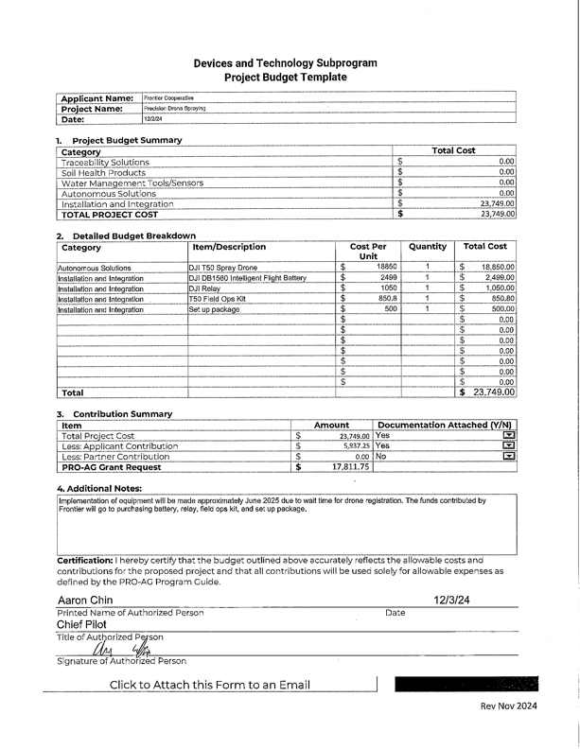

**Financial Projects**

Our financial projections were based on the three previous years of drone spraying. In 2022 we sprayed 2082 acres, in 2023, 5629 acres, and in 2024, 7717 acres, with respective revenues being $33,312, $90,064, and $123,472. We project that 2,000-3000 acres will be added each year for an additional revenue of $32,000-$48,000 per year. The initial cost of the drone and equipment will be $23,749 and that can be spread out over five years ($4,695.8 per year). Parts Cost: Annual Fixed Expense: $10,000. Fuel Costs (With 10% Annual Increase): Year Fuel Cost (USD) Year 1 10,000 Year 2 11,000 Year 3 12,100 Year 4 13,310 Year 5 14,641 Labor Costs Years 1–3: $80,000 annually, with an increase of $40,000 annually in year 2 which translates into year 3. Years 4–5: Increased to $160,000 annually.

**Cost Benefit Analysis**

Updated Annual Cost Breakdown

Parts Costs: Annual Fixed Expense: $10,000.

Fuel Costs (With 10% Annual Increase):

Year Fuel Cost (USD)

Year 1: 10,000

Year 2: 11,000

Year 3: 12,100

Year 4: 13,310

Year 5: 14,641

Labor Costs

Years 1–3: $80,000 annually, with an increase of $40,000 annually in year 2 which translates into year 3.

Years 4–5: Increased to $160,000 annually.

Updated Financial Table

Year Revenue (USD) Costs (USD, w/ Parts and Adjusted Labor) Net Profit (USD)

Year 1 155,472 134,749.80 20,722.20

Year 2 187,472 176,749.80 10,722.20

Year 3 219,472 178,949.80 40,522.20

Year 4 251,472 231,369.80 20,102.20

Year 5 283,472 234,031.80 49,440.20

Cost benefit Ratio

Total Costs = Sum of all costs (labor, fuel, parts, insurance, fixed costs).

Total Revenue = Sum of all revenues from spraying operations.

Total revenue is the sum of revenues over 5 years:

Total Revenue=155,472+187,472+219,472+251,472+283,472=1,097,360

Total costs include fuel, parts, labor, and other fixed expenses. Let's sum the total costs for each year:

Total Costs= 124,749.80+165,749.80+166,849.80+208,059.80+209,390.80=874,800.00 USD

CBR= 874,800/1,097,360.00≈0.80 CBR = 0.80

Conclusion

The Cost-Benefit Ratio (CBR) for this drone spraying operation is approximately 0.80, meaning that for every dollar spent, the operation generates $1.25 in revenue.