To Whom it may concern:

My operation is in an area where the local RTK network provider, 21st century equipment, does not have radio RTK coverage. It puts the operation in quite the predicament as we attempt to use boundaries and guidance lines that do not drift. We see accurate boundaries and guidance lines as the next big step for the operation as it will help us cut down on inputs and help us report properly. Being what the price of receivers are and the mixed fleet that we run with it is difficult to pay that much when it only works on the planting and tillage aspects of our crop cycle as we utilize Case guidance for the sprayer and combine.
Currently, the best option for our farm is SF3 on a 6000 receiver, but the repeatability is only guaranteed for 9 months meaning the boundaries won’t be sustainable for even one growing season.
We have a newer 8R tractor which is capable of running an integrated SF7500 receiver. That and a universal SF7000 receiver for our other machine would allow us to utilize SF-RTK. SF-RTK adds a new satellite datum and in doing so John Deere was able to create a satellite GPS connection that is more accurate than radio based RTK but without the use of base stations. The accuracy plus the guaranteed 5 year repeatability will greatly increase the capability to use AutoTrac(turn automation and Autopath from boundary) and section control. This advancement will directly increase efficiency for our operation.
The final point is that John Deere projects a fully autonomous farming solution by 2030. SF-7000 or SF-7500’s will be required for automation features moving forward meaning if your accuracy is too low you are not a candidate for those labor saving features when they become available.
One of the many benefits of going this direction is the direct use of the John Deere operations Center which lets us monitor field productivity and machine performance all in one. Allowing us to see the immediate impact of this project.
See the Photos of 21st Century Radio RTK coverage map and my Area of Responsibility notice the lack of intersection.
I appreciate the consideration of this grant and look forward to hearing from you shortly.

-Matt Klingsman


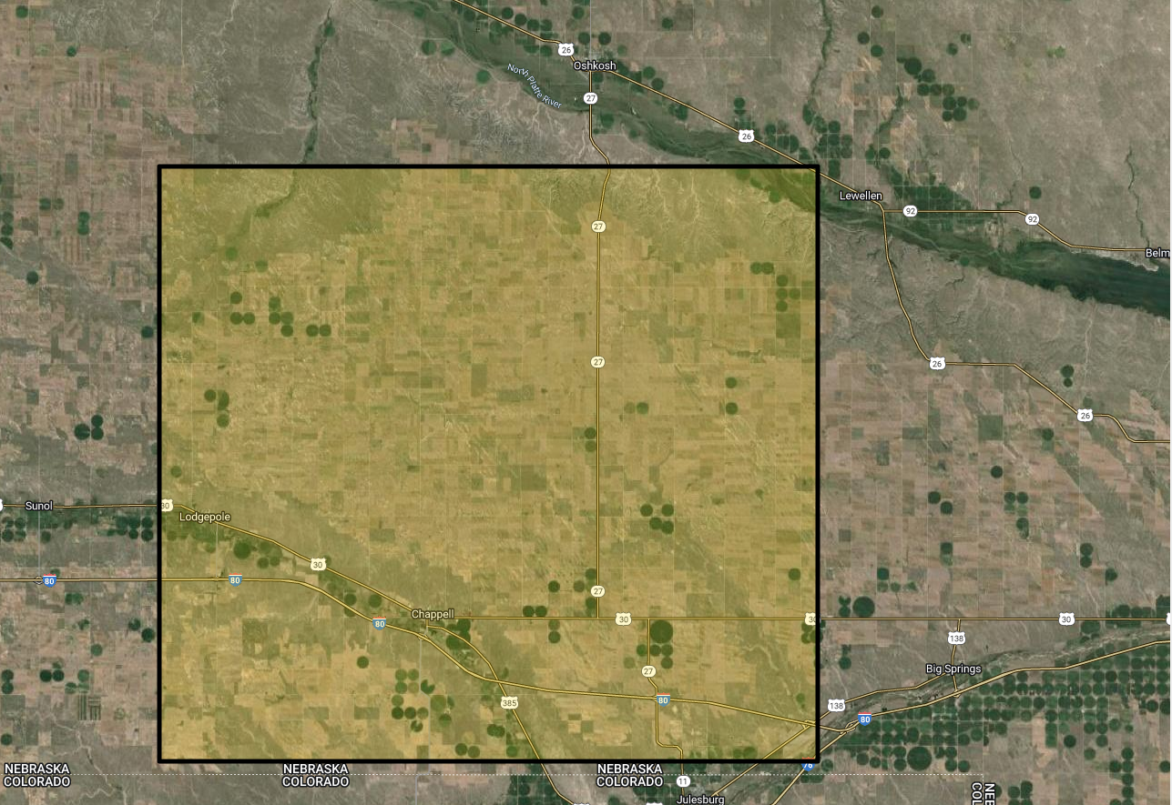
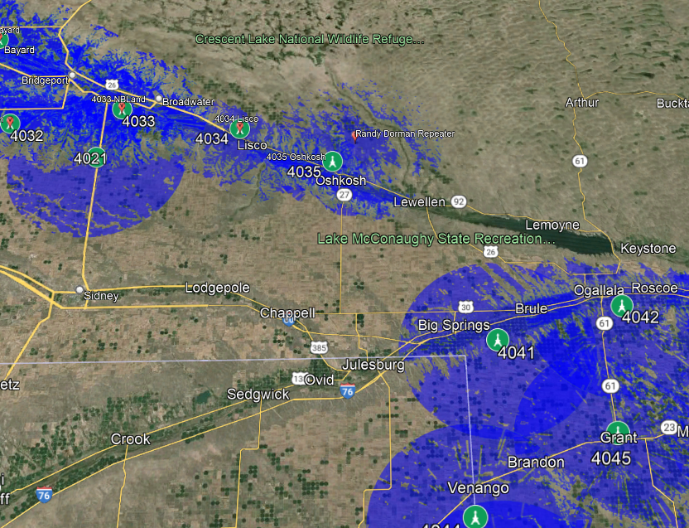
RTK Tower Area of Effect
Matt Klingman’s Area of responsiblity

